How the Work Got Done
Text: Nehemiah 3
Pastor Gregg Cantelmo • March 5, 2023

Many workers were involved in building and repairing (word used 40x), the wall of Jerusalem. The walls and gates were important of the people and the beauty of the city. There was a place for everybody who had a mind to work. They cooperated and served the Lord together.
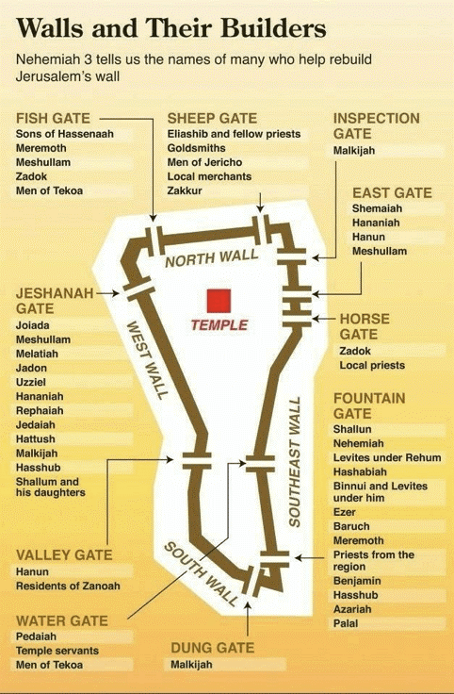

How the Work Got Done
Text: Nehemiah 3
Pastor Gregg Cantelmo • March 5, 2023

Many workers were involved in building and repairing (word used 40x), the wall of Jerusalem. The walls and gates were important of the people and the beauty of the city. There was a place for everybody who had a mind to work. They cooperated and served the Lord together.

