The Source and Course of Sin
Series: A Faith That Works, James 1:13-18
Pastor Gregg Cantelmo
April 14, 2019

When you realize how good God is to you, you will have no interest in the temptations the enemy puts before you. When you are tempted, count your blessings, and you will soon have strength to say no.
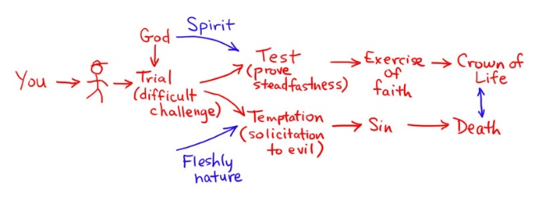
Trial or Temptation?

THE SOURCE
(vv. 13-14):

THE COURSE (vv. 15-18):

-- Conception – Birth – Death

THE FORCE: What can we do to overcome temptation?

- Practice S______ E______________.
- Pray for God’s P____________ to withstand any temptation He allows in your life.

- Turn to C___________ for special help in time of need.
- F_________ the temptation to sin.
- D____________ the instrument of sin and temptation.
- Keep good C_______________.

