Laodicea: Yuck!
Series: What Christ Thinks of the Church; Revelation 3:14-17
Pastor Gregg Cantelmo
April 17, 2016

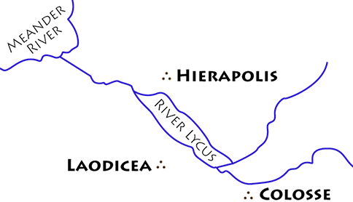
Christ’s messages to the seven churches in Asia come to a close with a tragic letter to the self-sufficient, self-righteous, self-serving church in Laodicea. In their inexhaustible wealth and independent spirit, the Laodiceans were severely rebuked by the One who knew them better than they knew themselves.

SETTING:

SPEAKER:

- The Amen =

- The Witness =

- The Creator =

STRENGTHS:

SIN (vv. 15-17):

Cold = to be spiritually I____________ or A______________

Hot = to be on F__________ for God

Lukewarm = to be H___________ and H______________

Why would Christ rather that they be cold or hot?

Reason #1 deals with our R__________________ with Christ.

Reason #2 deals with our I_______________ for Christ.

